Question:
Find the forward difference table using Infinite Forward Method using Python.
Aim:
Write a Python program to demonstrate to generate and display the forward difference table using Infinite Forward Method.
Program:
def forward_difference_table(x, y):
n = len(y)
diff_table = [y.copy()] # First row is just y values

# Generate the forward difference table
for i in range(1, n):
row = []
for j in range(n - i):
value = diff_table[i - 1][j + 1] - diff_table[i - 1][j]
row.append(value)
diff_table.append(row)

return diff_table

def display_table(x, diff_table):
n = len(x)
print("\nForward Difference Table:")
print("x\t" + "\t".join([f"Δ^{i}y" for i in range(n)]))

for i in range(n):
row = [f"{x[i]:.2f}"]
for j in range(n - i):
row.append(f"{diff_table[j][i]:.2f}")
print("\t".join(row))

def main():
# User input
n = int(input("Enter the number of data points: "))

print("Enter x values (equally spaced):")
x = [float(input(f"x[{i}]: ")) for i in range(n)]

print("Enter corresponding y values:")
y = [float(input(f"y[{i}]: ")) for i in range(n)]

# Check equal spacing
h = x[1] - x[0]
if not all(abs(x[i + 1] - x[i] - h) < 1e-5 for i in range(n - 1)):
print("Error: x values are not equally spaced.")
return

# Compute and display the forward difference table
diff_table = forward_difference_table(x, y)
display_table(x, diff_table)

if __name__ == "__main__":
main()
Result:
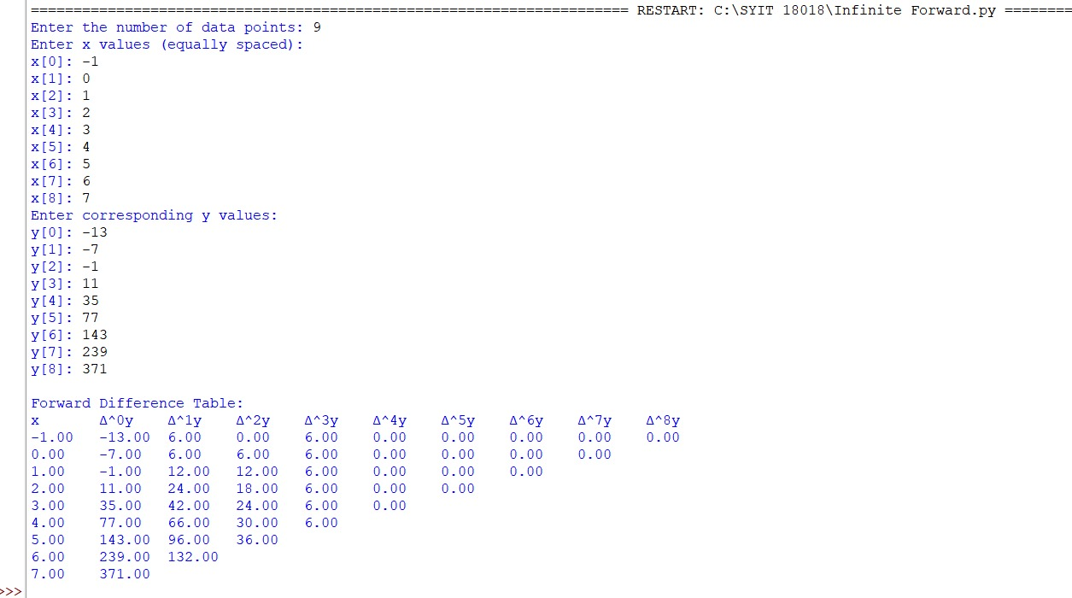

Conclusion:
The above Python program has been executed successfully.

